CLOUD COMPUTING TECHNOLOGIES
Skill Assessment Test – 2
Name : Srileka B
Reg no : 722824148305
COMPLIANCE AUDITING
ROUND 2
i) IMPLEMENT AWS STORAGE
STEPS
Step 1: Open S3
- Login to your AWS Management Console.
- Search for S3.
- Click S3 → Create bucket.
Step 2: Create the bucket
Enter a unique bucket name, for example:
cloud-lab-storage-2026-yourname
Select:
- AWS Region: Asia Pacific (Mumbai) – ap-south-1
- Block all public access: Keep enabled
- Bucket Versioning: Enable
- Leave other settings as default.
Click Create bucket.
Step 3: Upload a file
- Open the newly created bucket.
- Click Upload.
- Click Add files.
- Select a file such as:
sample.txt
- Click Upload.
Step 4: Verify the object
After uploading, the file should appear inside the bucket.
You can demonstrate:
- Object name
- File size
- Storage class
- Last modified time
Step 5: Create a folder
Inside the bucket:
Create folder → application-data
Then upload another file into this folder.

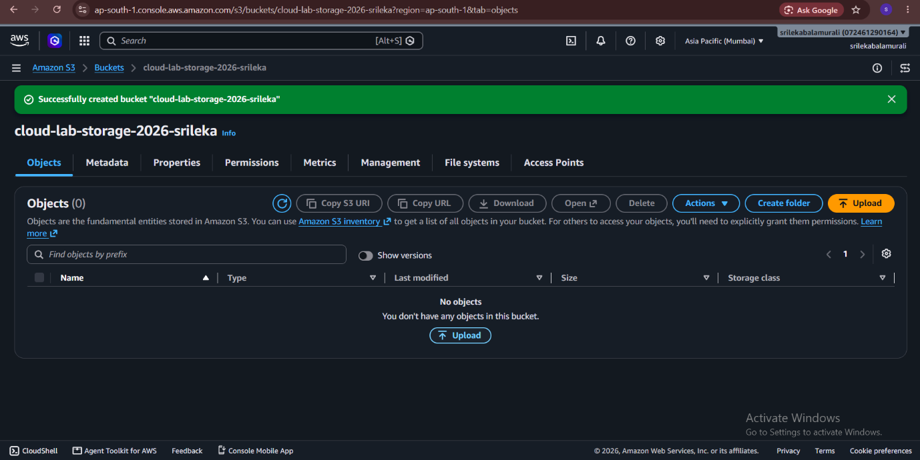

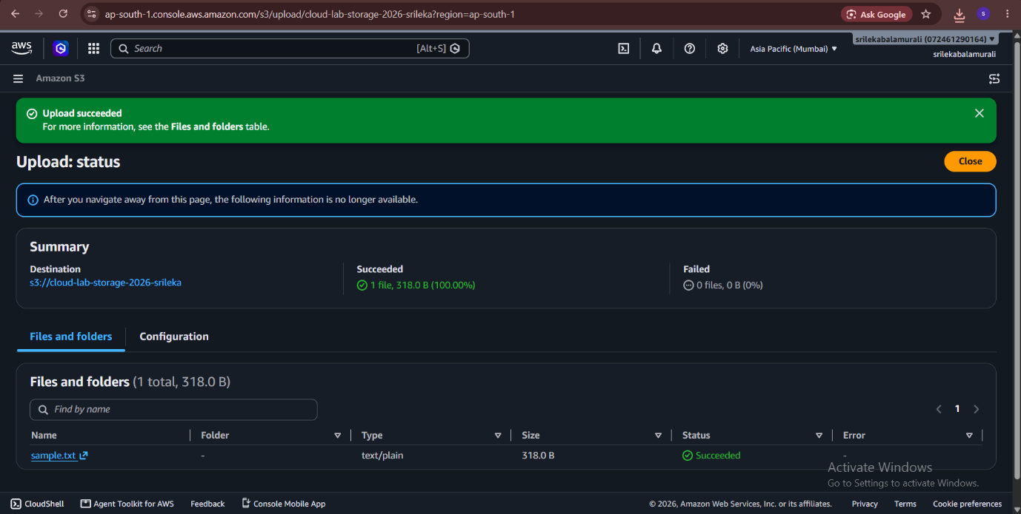
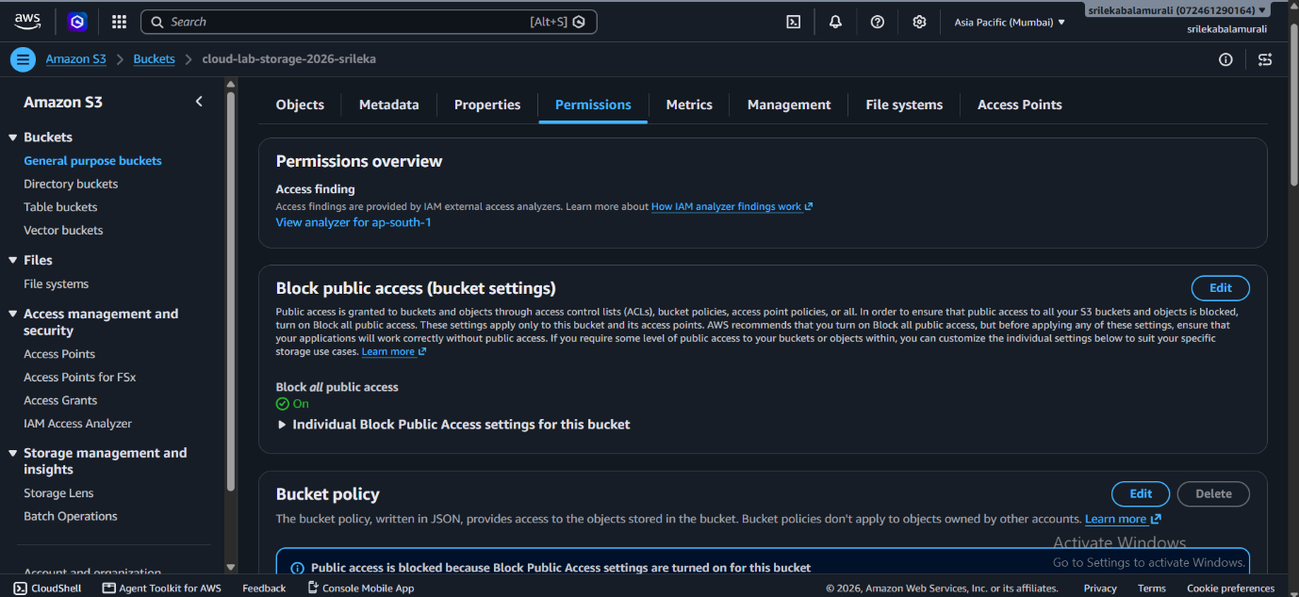

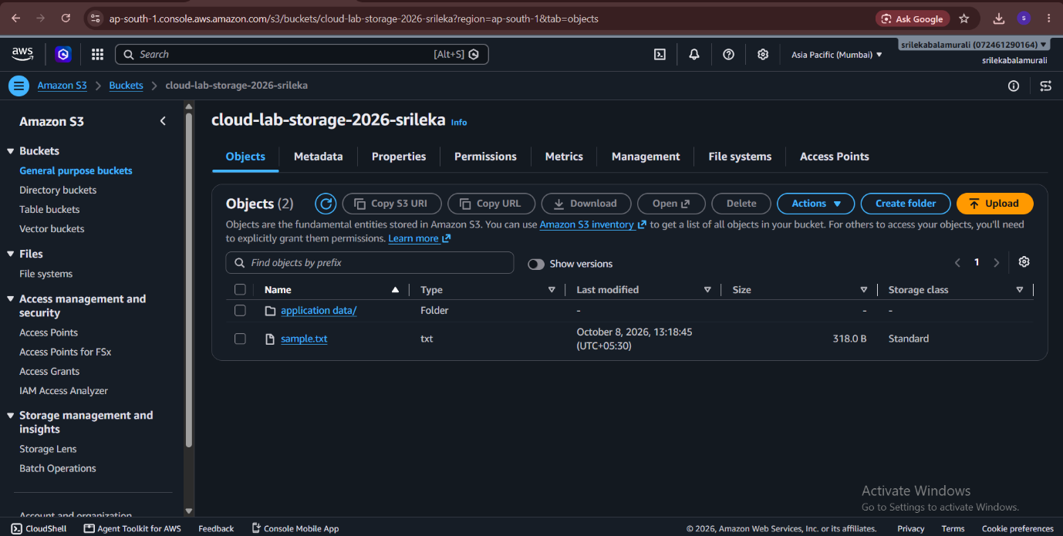
ROUND 2
ii) BUILD END-TO-END AWS SOLUTION
STEPS
1. Create VPC and Subnets
- Open AWS Console → VPC.
- Click Create VPC.
- Select VPC and more.
- Enter a name, e.g. End-to-End-VPC.
- Create 1 public subnet and 1 private subnet.
- Keep Internet Gateway enabled.
- Click Create VPC.
2. Create EC2 Web Server
- Go to EC2 → Instances → Launch Instance.
- Select Ubuntu.
- Choose the VPC you created.
- Select the public subnet.
- Enable Auto-assign Public IP.
- Create/choose a security group allowing SSH (22) and HTTP (80).
- Launch the instance.
- Connect using EC2 Instance Connect or SSH.
- Install a web server:
sudo apt update
sudo apt install apache2 -y
- Test using the EC2 Public IPv4 address in your browser.
3. Create S3 Storage
- Go to S3 → Create bucket.
- Enter a unique bucket name, e.g. my-end-to-end-storage.
- Keep Block all public access enabled.
- Click Create bucket.
- Open the bucket → Upload → Add files.
- Upload your sample.txt or application file.
4. Create RDS MySQL
- Go to RDS → Databases → Create database.
- Select MySQL.
- Choose Free tier if available.
- Set a database name, username and password.
- Select the VPC created earlier.
- Place RDS in the private subnet.
- Create/choose a security group for RDS.
- Allow MySQL/Aurora – port 3306 from the EC2 security group, not from 0.0.0.0/0.
- Click Create database.
5. Connect EC2 with RDS and S3
- From EC2, install the MySQL client:
sudo apt install mysql-client -y
- Connect using the RDS endpoint:
mysql -h RDS-ENDPOINT -u USERNAME -p
- Enter your RDS password.
- Test by creating a database/table or running a query.
- Your EC2 can also access S3 using AWS CLI if the required IAM permissions are configured.
6. Enable CloudWatch Monitoring
- Go to CloudWatch → Dashboards.
- Check EC2 monitoring metrics such as CPU utilization.
- You can create a dashboard and add EC2 metrics.
- Verify that EC2, S3 and RDS are running/accessible.

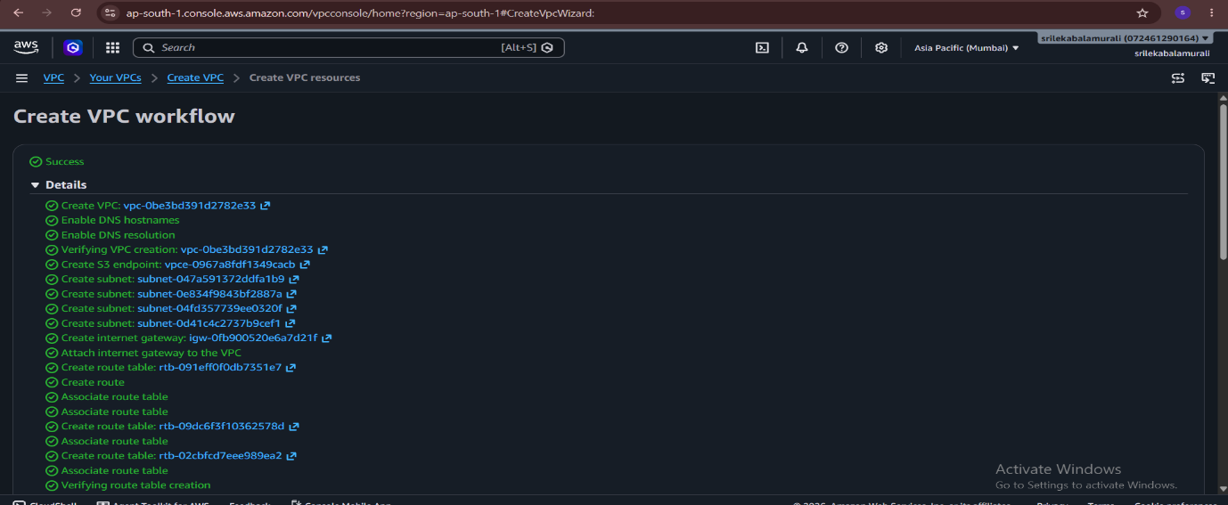

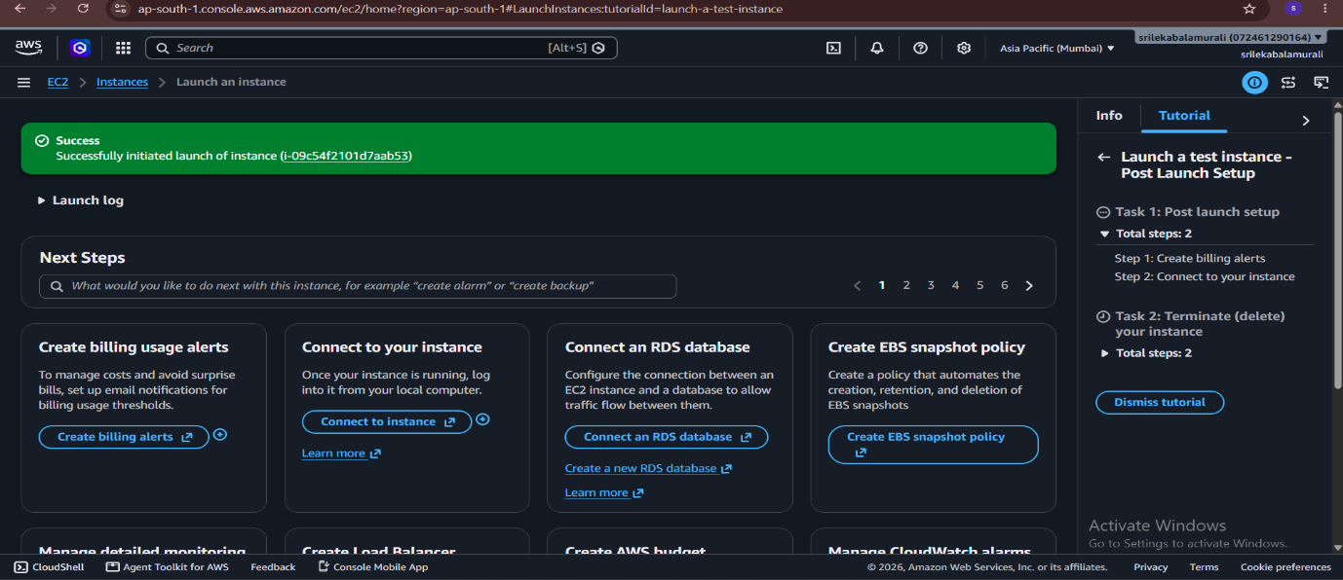

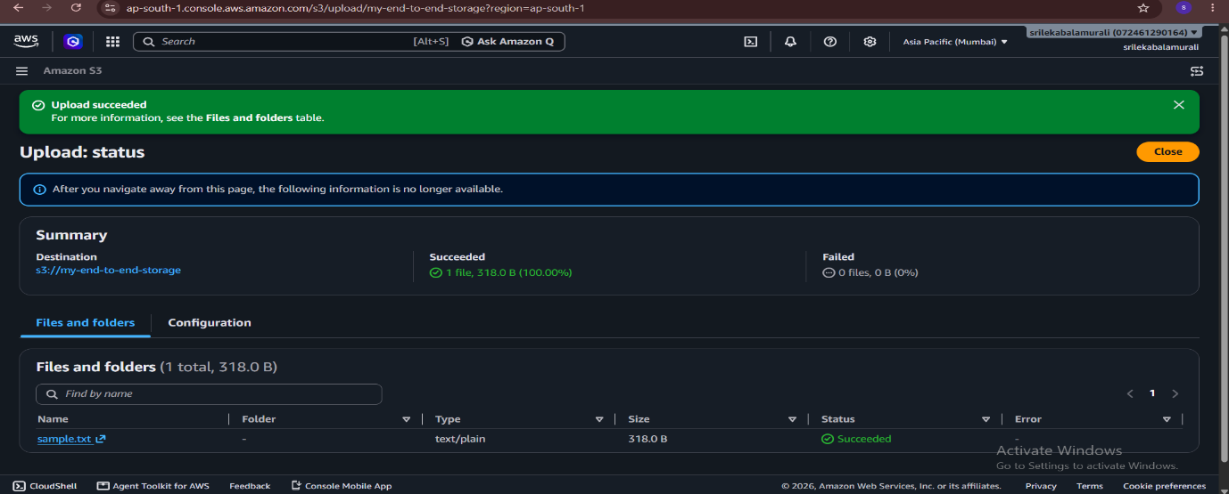
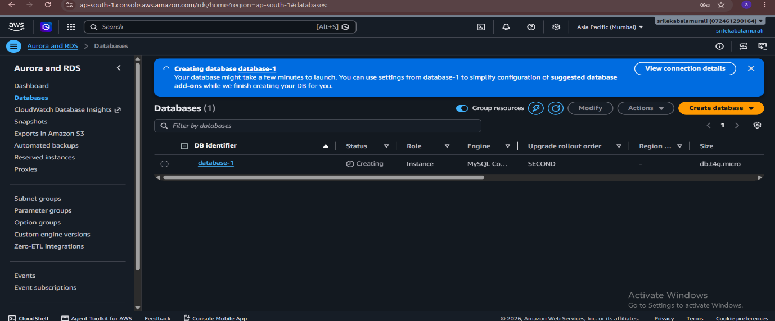

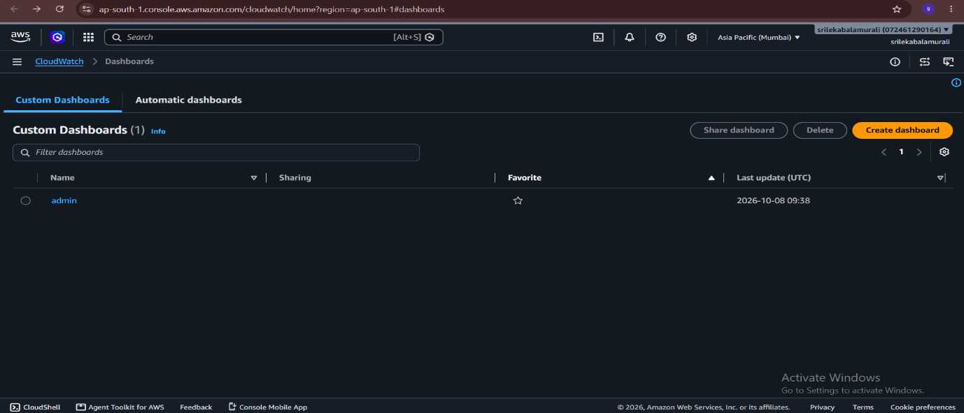

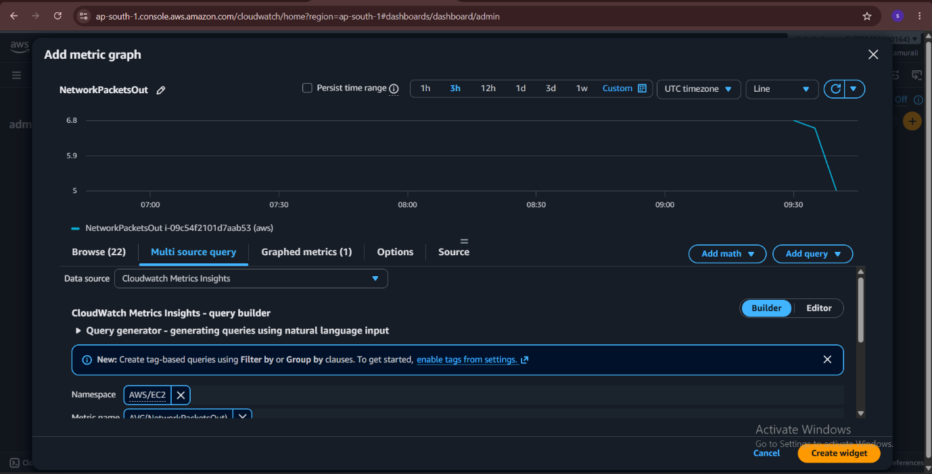
ROUND 3
DATA INTEGRATION AND DEPLOYMENT
STEPS
1. Enable CloudWatch Logging in CloudTrail:
- Go to CloudTrail → Select your Trail (FinServe-Audit-Trail).
- Scroll to CloudWatch Logs → Click Edit.
- Enable CloudWatch Logs and create/select a Log Group (e.g., /aws/cloudtrail/FinServe-Logs).
2. Create Amazon SNS Topic for Alerts:
- Go to Amazon SNS → Topics → Click Create topic.
- Choose Standard, name it FinServe-Security-Alerts, and click Create topic.
- Click Create subscription → Protocol: Email → Enter your email address → Confirm the subscription from your email inbox.
3. Create CloudWatch Metric Filter:
- Go to CloudWatch → Log groups → Select /aws/cloudtrail/FinServe-Logs.
- Click Metric filters tab → Create metric filter.
- Enter a pattern to catch sensitive events (e.g., { $.eventName = "PutBucketPolicy" || $.eventName = "AttachRolePolicy" }).
- Name the metric (e.g., UnauthorizedPolicyChanges) and click Save.
4. Deploy CloudWatch Alarm:
- From the metric filter, click Create alarm.
- Set threshold: Greater/Equal to 1 for a 1-minute period.
- Under Notification, select In alarm and choose your SNS Topic (FinServe-Security-Alerts).
- Name the alarm FinServe-Compliance-Violation-Alarm and click Create alarm.
5. Test and Verify the Deployment:
- Perform a test activity (e.g., modify an S3 bucket policy or IAM role).
- Go to CloudWatch Logs Insights, run a query, and verify the log entry is captured.
- Verify that the CloudWatch Alarm triggers (In Alarm state) and delivers an email notification via SNS.

